# Experiment 5: ARQ Mechanisms in DLL

**Aim:** To implement receiver algorithms for the different ARQ mechanisms at the Data Link Layer

**Objective:** After carrying out this experiment, students will be able to:

* implement receiver algorithms for the different ARQ mechanisms at the Data Link Layer
* Analyze the differences between the ARQ mechanisms

**Problem statement:** You are required to write a program that can receive frames at the data link layer. Assume that the user is entering the frames as the transmitter. You are required to implement stop and wait, go back N and selective repeat ARQ mechanisms. Consider that you have to transmit and receive a total of 20 frames using WT=WR=1, WT=5 and WR=1 and WT=WR=5 for stop and wait, go back N and selective repeat respectively

**Analysis:** While analyzing your program, you are required to address the following points:

* Difference between stop and wait, go back N and selective repeat.
* Comparison of the disadvantages of the different ARQ mechanisms.

**MARKS DISTRIBUTION**

|  |  |  |
| --- | --- | --- |
| Component | Maximum Marks | Marks Obtained |
| Preparation of Document | 7 |  |
| Results | 7 |  |
| Viva | 6 |  |
| Total | 20 |  |

Submitted by: Deepak R

Register No: 18ETCS002041

1. **Algorithm/Flowchart**

Algorithm for Go Back N ARQ-

* Enter the size of the frames i.e. the sequence number.
* The transmitted frames will be equal to the $2^{f}-1$ where f is the sequence number.
* The data to be transmitted can be generated using a loop and stored in the array arr[n].
* The timer for the acknowledgement can be set by using the data type clock in the library <time.h>.
* In case of Go back N ARQ the data is sent in a set of frames which is equal to transmitted frame length discussed earlier. Thus, a for loop is used to sent the first window of frames.
* The acknowledgement can generate any number between the window length which will denote the number of frames received correctly.
* The received frames will be given by using a for loop from the previous received (received initially at 0) to the received plus acknowledged frame thus if the frame id not acknowledged it is sent again.
* If the time taken to receive acknowledgement is less than the timer then the frame is sent again.
* This is repeated for all the frames using a while loop.

Selective Repeat ARQ-

* Enter the size of the frames i.e. the sequence number.
* The transmitted frames will be equal to the $2^{f}-1$ where f is the sequence number.
* The data to be transmitted can be generated using a loop and stored in the array arr[n].
* The timer for the acknowledgement can be set by using the data type clock in the library <time.h>.
* In case of selective repeat the frame for whose negative acknowledgement NAK is received is sent again.
* To avoid sorting we are sending the frames one at a time.
* The rest is same as Go Back N.

1. **Program**

**Program to perform Go back N**

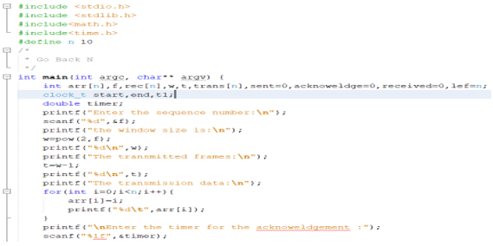

*Fig1: Screenshot of the “Go Back N” Sliding Window Protocol*

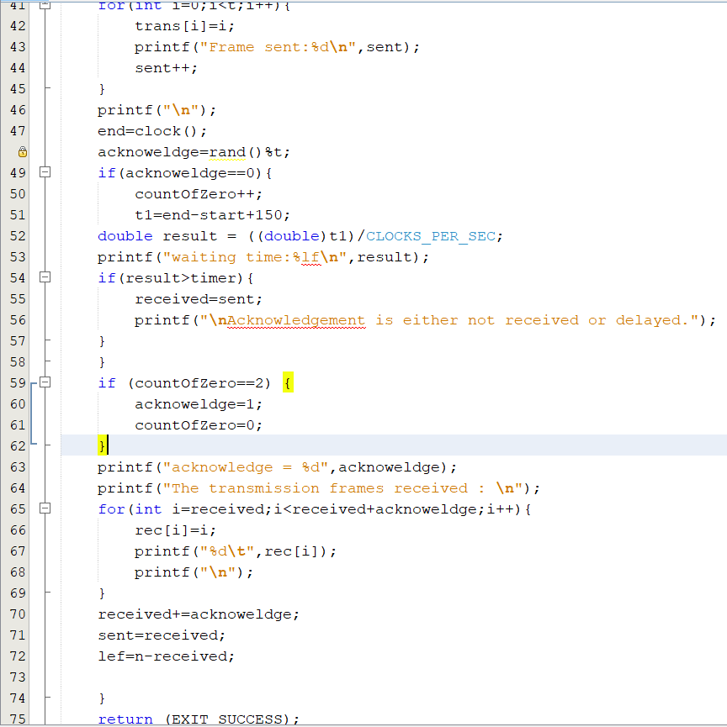

*Fig2: Screenshot of the “Go Back N” Sliding Window Protocol*

Program to perform Selective Repeat ARQ

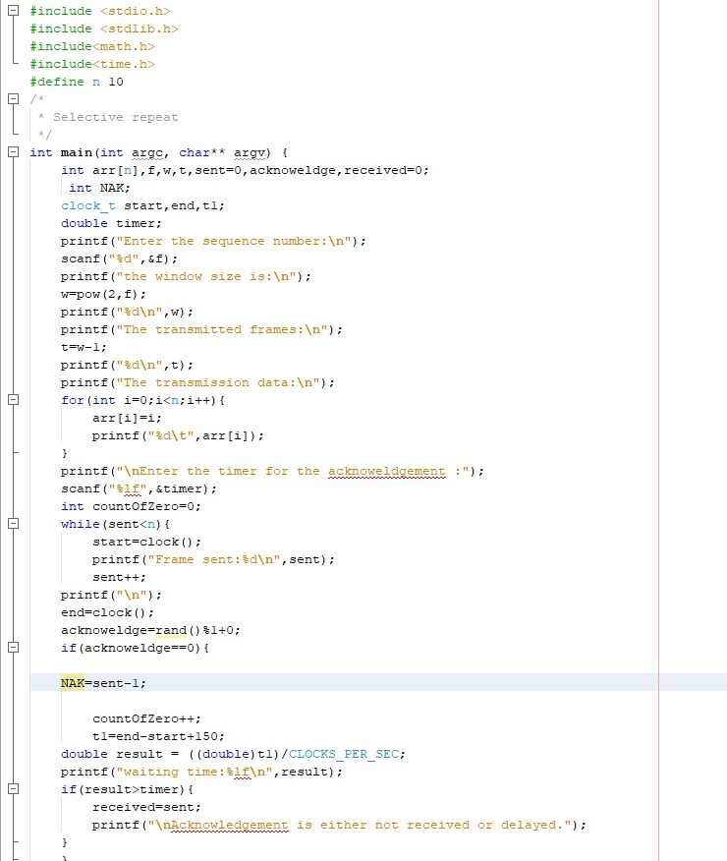

*Fig3: Screenshot of the selective Repeat Protocol*

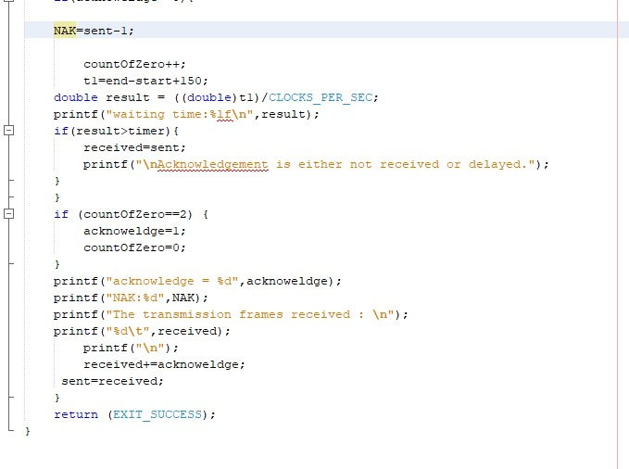

*Fig4:Screenshot of the selective Repeat Protocol*

1. **Results**

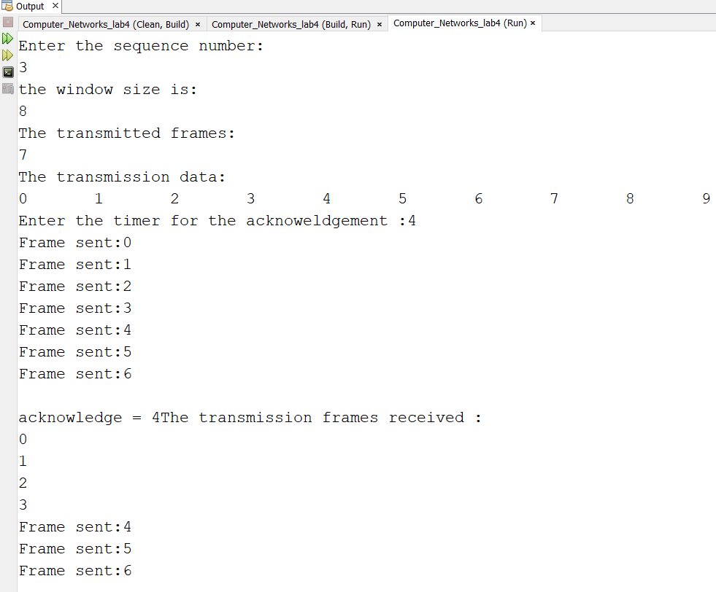

*Output of the “Go Back N” Sliding Window Protocol.*

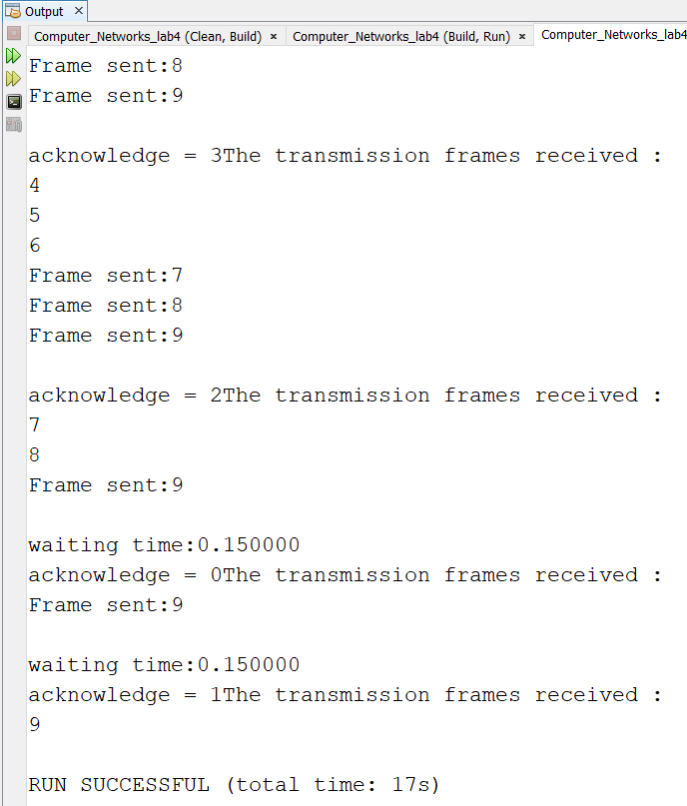

*Output of the “Go Back N” Sliding Window Protocol*

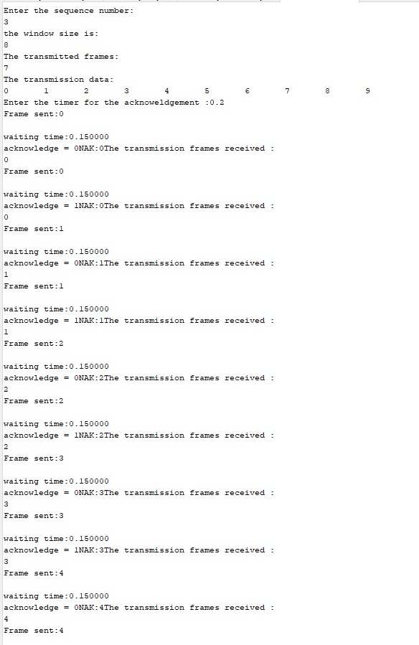

*Output of the selective repeat Protocol*

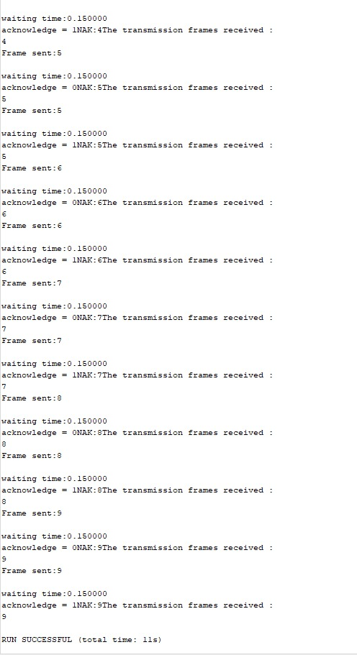

*Output of the selective repeat Protocol*

1. **Analysis and Discussions**

The main purpose of this experiment was to execute the receiver end program for the different ARQ protocols there are basically three types of protocol out of which two are using the sliding window protocal and the other one uses the static protocol.

In go back and N protocol the receiver has a window size of one and the sender has a window size of 2m-1. The sender sends all the frames in that window within the given time period one after the other now the sender will wait for an acknowledgment from the receiver. The receiver can send a cumulative acknowledgment saying that all the frames till that region was received. Now the sender and receiver window will be updated depending on the acknowledgement receiver in the event that a frame or acknowledgment is lost and no acknowledgement is received by the received. Then the sender will retransmit all the frames in that window. This is better than go back and n looking at the fact that number of retransmission is less and also the rate of transmission is higher. But there is a disadvantage that there is still a really high chance of duplication in a noisy channel.

In case of selective repeat the sender and the received has the same window size which is defined by using the formula 2m/2. The sender sends all the data in the given window one after the other. Now the received can store all these data received in the given position in the window so even if the data comes out of order it is not a problem. Acknowledgement all the data which is addressed is sent by the receiver and in the event a frame is lost and the next frame arrives then the receiver will send a negative acknowledgment of the sender asking for only the frame which was not receiver by the receiver. In this way both bandwidth and the probability of duplication of data can be overcome. This is an effective method of transmission in a noisy channel along with packet switching.

* **Difference between stop and wait, go back N and selective repeat:**

|  |  |  |
| --- | --- | --- |
| STOP AND WAIT | GO BACK N | SELECTIVE REPEAT |
| Stop-and-wait ARQ, also referred to as alternating bit protocol, is a method in telecommunications to send information between two connected devices. It ensures that information is not lost due to dropped packets and that packets are received in the correct order. It is the simplest automatic repeat-request (ARQ) mechanism. A stop-and-wait ARQ sender sends one frame at a time. | “Go-Back-N Protocol is one of the sliding window protocols. The sliding window protocol is primarily an error control protocol, i.e. it is a method of error detection and error correction. The “go-back-n protocol” retransmits all the frames that lie after the frame which is damaged or lost. | “Selective Repeat Protocol” is one of the sliding window protocols.  It retransmits only those frames that are suspected to lost or damaged. |
| In this case the window size at the transmitter and the receiver is equal to one or greater than one respectively. | Here the window size is  N-1. | Here the window size is  <= (N+1)/2 |
| It only sends acknowledgment for the packet received by the receiver. It doesn’t send negative acknowledgment. | It doesn’t send negative acknowledgment for the data that is not received or the for the data that have any error. It only sends acknowledgment. | It sends a negative acknowledgment for the lost frames. |
| It has more delay time and is inefficient as compared to the other two ARQ mechanisms. | It requires large bandwidth. | It requires buffer space. |

* **Comparison of the disadvantages of the different ARQ mechanisms:**

|  |  |  |
| --- | --- | --- |
| STOP AND WAIT | GO BACK N | SELECTIVE REPEAT |
| Window size at sender and receiver is equal to 1.  (disadvantage) | Sender window size is 2^n-1 and the receiver window size is 1. | Sender window and the receiver window size is equal to 2^n-1. |
| There is no pipelining. (disadvantage) | Pipelining is implemented. | Pipelining is implemented. |
| It takes more delay time i.e. has large delay time. (disadvantage) | It requires large bandwidth. (disadvantage) | It requires buffer space.  (disadvantage) |
| Sorting is not required, the data is received in the correct order. | Sorting is not required, the data is received in the correct order. | Receiver may receive the packets out of sequence which is one of the disadvantages and therefore sorting is required. |

1. **Conclusions**

In this lab experiment we discussed the concept of ARQ. We conclude that ARQ mechanism is an error-control method for data transmission that uses acknowledgements and timeouts to achieve reliable data transmission over an unreliable service. The different kinds of ARQ mechanism as mentioned above are stop and wait, go back N and selective repeat and all these three are a kind of sliding window protocol. It can be concluded that out of all the three protocols the selective repeat protocol is the most efficient because it sends a negative acknowledgment and in addition to this it sends only the frame that has been not received by the receiver (i.e. sends only that frame that is suspected to be lost or damaged and therefore avoids the delay time but it needs buffer space. On the other hand, the stop and wait protocol has more delay time and is not efficient if the frame is thick and long and it does not send a negative acknowledgment for the lost or damaged frames. Similarly, the go back N protocol also doesn’t send negative acknowledgment and in addition to this it retransmits all the frames that lie after the frame which is damaged or lost and thus wastes bandwidth.

1. **Comments**
   1. **Limitations of the experiment and result**

* Go Back N sliding window protocol retransmits all the frames that lie after the frame which is damaged or lost and thus wastes bandwidth
  1. **Limitations of the results obtained:**
* The window size and bandwidth product is large for GO Back N protocol.
  1. **Learning happened**
* In this lab we learnt about the concept of different ARQ mechanism and also about its implementation. The design issue of data link layer one among is flow control. The disadvantages and the methods to overcome these protocol. About stop and wait with its disadvantages